**Day -5  
  
Name - Rishabh Manchanda**

**Employee ID:**

**109883998**

**Task 1- 37**  
  
  
**LINUX   
  
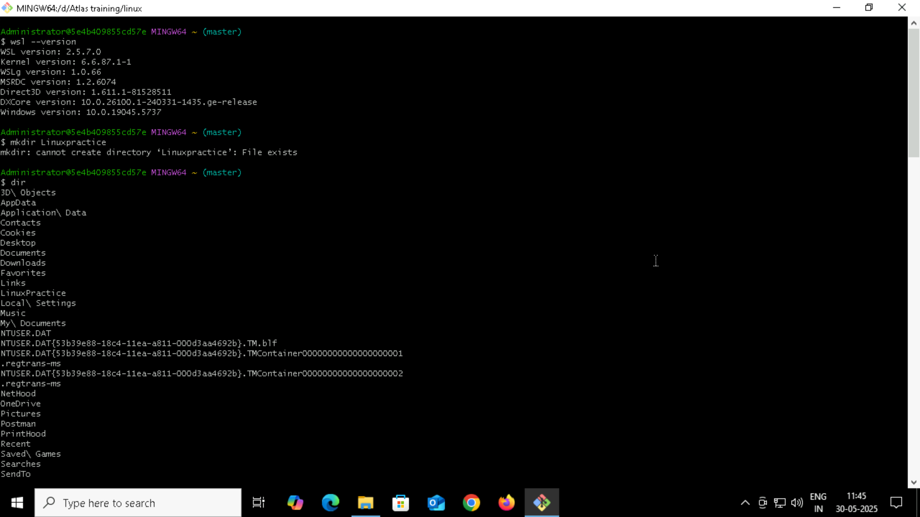**

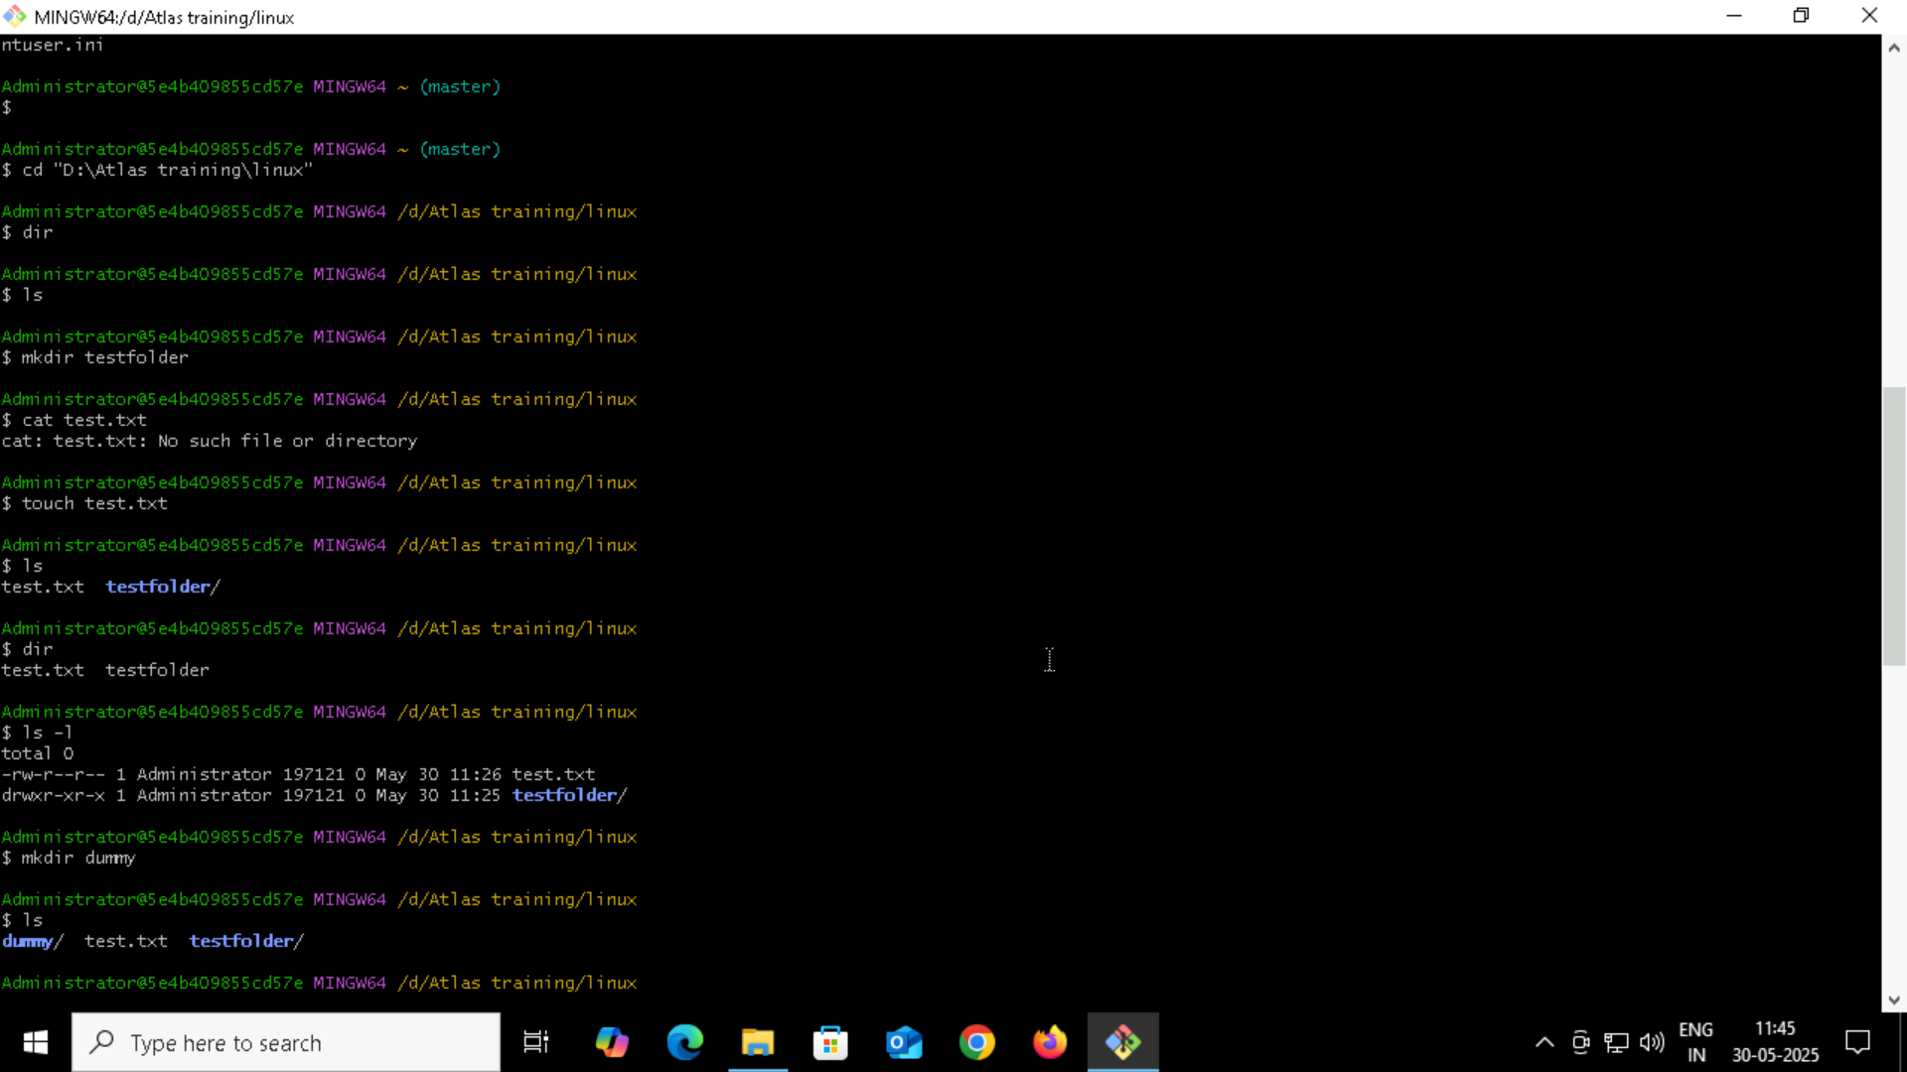

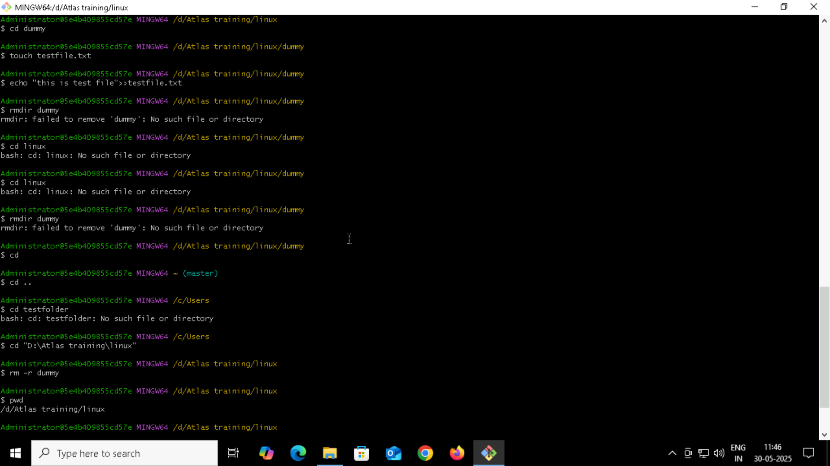

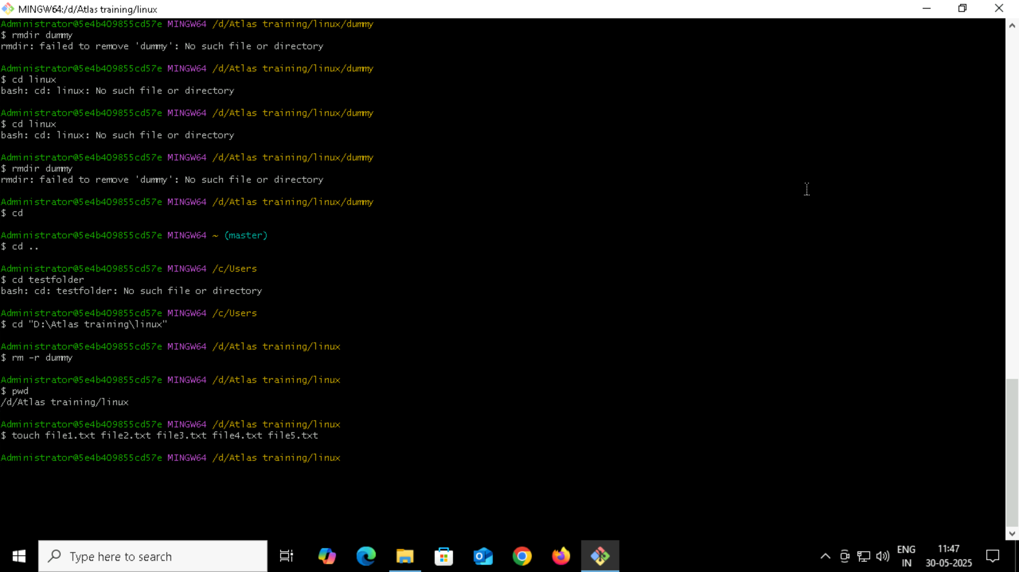

**RM is used to remove text file and RMDIR is used to remove empty folder**

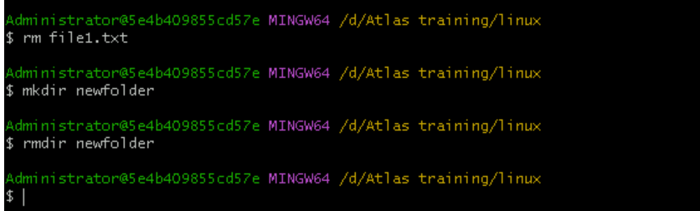

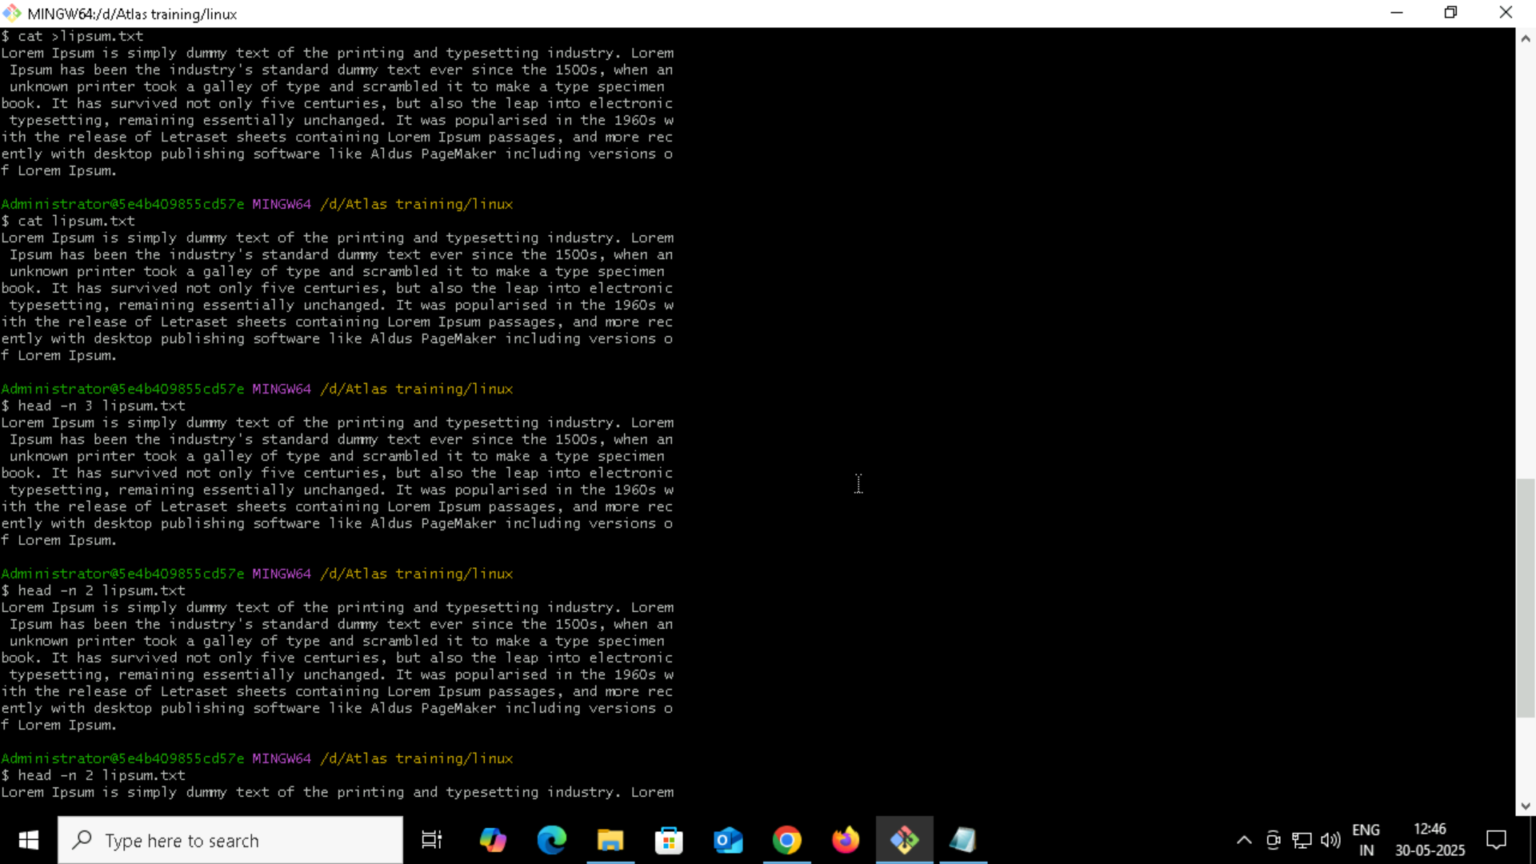

**The -e option in echo enables interpretation of backslash escapes like \n**

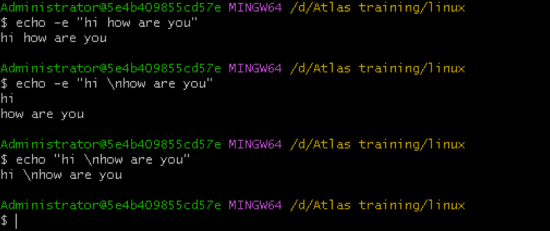

**Calendar**

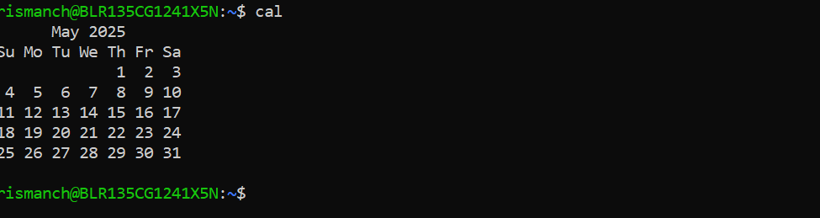

**Going back to the command at a time  
  
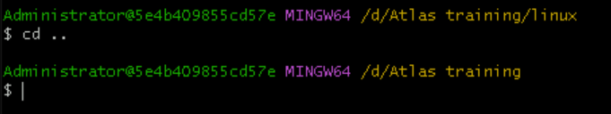**

**WHOAMI**

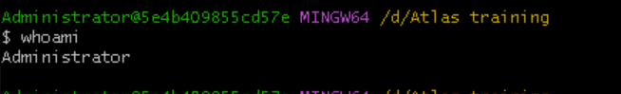

**Try to find out who is peeping into your system**

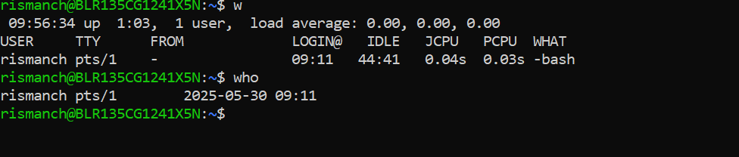

**Copy data from one folder to other ;**

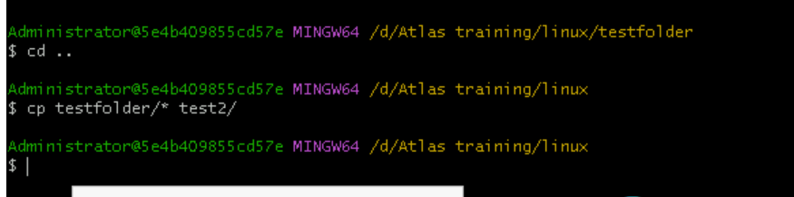

**try to check how much disk space is consumed**

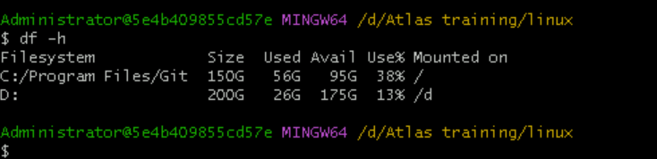

**What is the difference between . and .. in linux**

**Line 1 line for each**

. refers to the current directory you are in.

.. refers to the parent directory (one level up).

**How to find the no of words in the file**

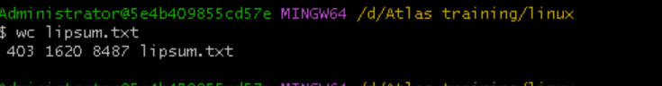

**What is the use of cat -b myfilename.txt command?**

**This numbers all lines, including blank ones.**

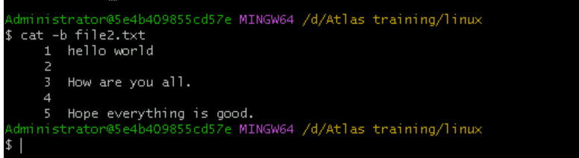

**Can I use the wc with 2 or more files**

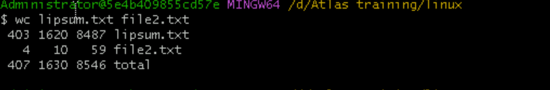

**Now I want to rename my file with MYFILENEW can i do that if so how**

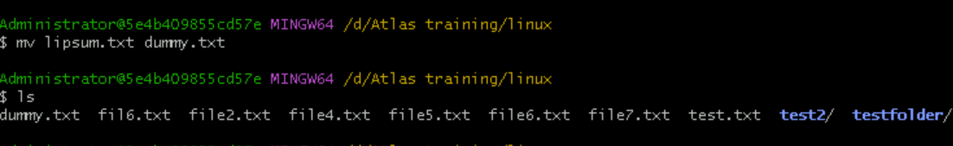

**Can I remove or delete multiple files in linux..? How?**

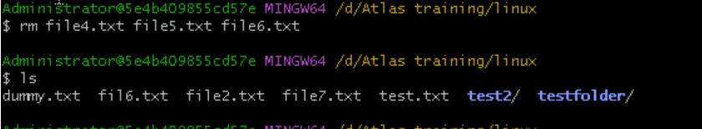

**CAT /ETC/PASSWD**

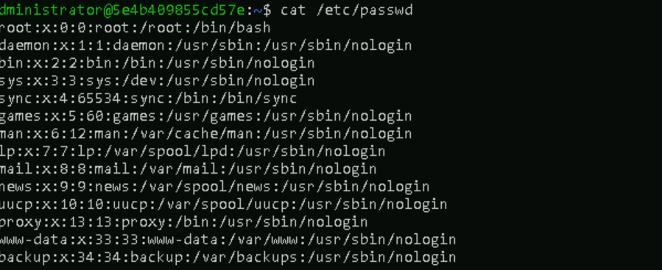

**Add new user**

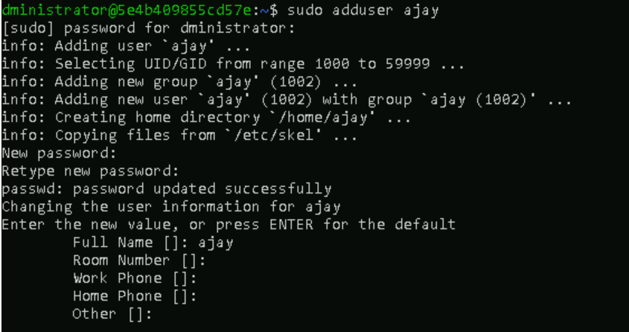

**Vi editor   
  
